**Group #1**

**Rudrashis Poddar**

**Balaji Arcot Kulasekaran**

**Harsh Kantilal Sharma**

**Rabie Ahmed M Alsaihati**

**University of Cincinnati**

**College of Applied Science and Engineering**

**Machine learning**

**Professor Anca Ralescu**

**Homework three**

1. **Basic ID3 Algorithm**

For this assignment, the ID3 and the naives bayes algorithms were implemented.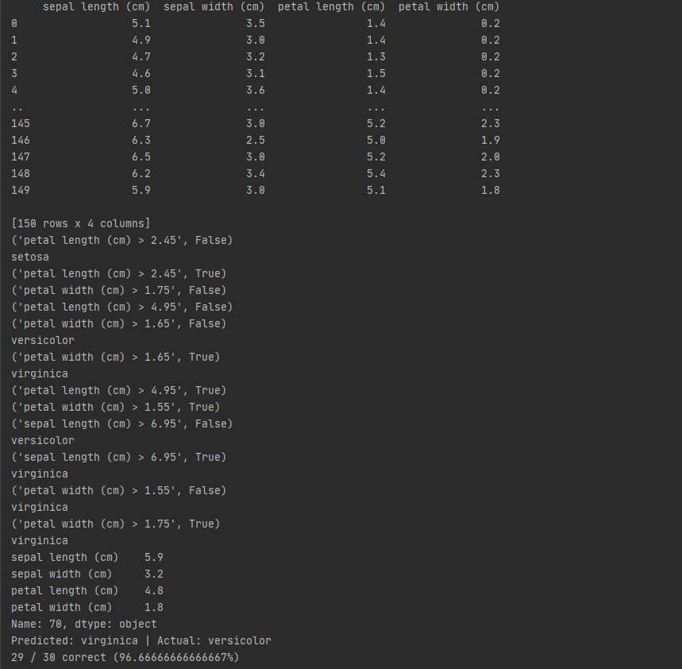

Figure shows the output for ID3 implementation

1. **Accuracy plots and mean for different bins**

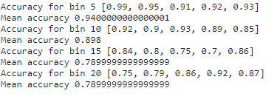

Figure shows accuracy for different bins, mean accuracy, max and lowest.

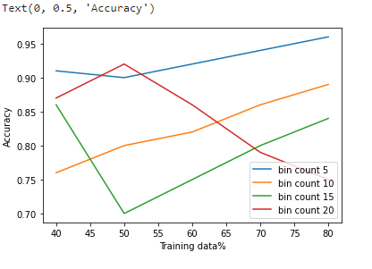

Figure shows accuracy plot for different bins

1. **F1 Score plot**

Figure shows f1 scores for different bins

1. **Naïve bayes output**

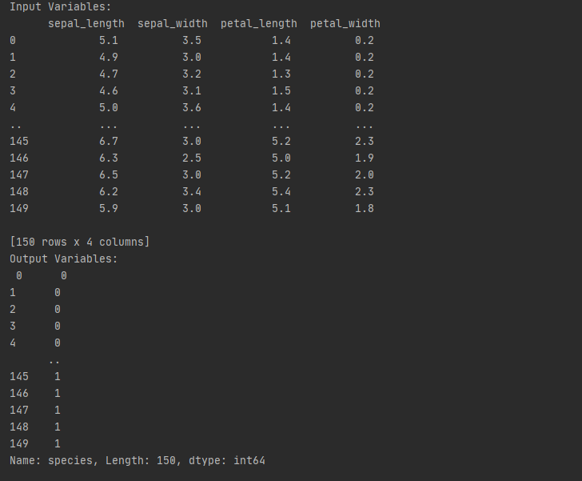

1. **Naïve bayes accuracy**

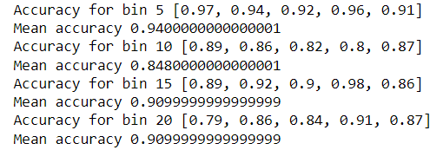

**Accuracy for Naïve Bayes**



Figure shows accuracy for naive bayes

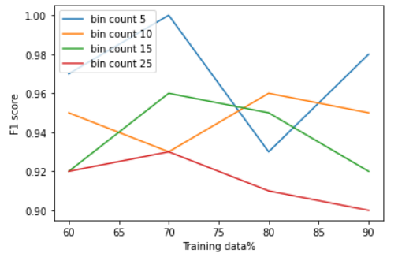

Figure shows the f1 scores for naive bayes